24th , Sept, 2026
LAB: 02

Introduction of NumPy

Submitted By: Shafi Azam
Registration No: (SP24-BAI-047)
Submitted To: Sir Anayat Ullah
Subject: ANN And Deep Learning



Department of Computer Science
Comsats University Islamabad
Islamabad Campus

Activity: 01

#Load Library
import numpy as np

#Create a Matrix
matrix = np.array([[1,2,3],[4,5,6]])
print(matrix)

Output:
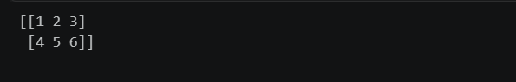

Activity: 02

#Load Library
import numpy as np

#Create a vector as a Row
vector_row = np.array([ 1,2,3,4,5,6 ])

#Create a Matrix
matrix = np.array([[1,2,3],[4,5,6],[7,8,9]])
print(matrix)

#Select 3rd element of Vector
print(vector_row[2])

#Select 2nd row 2nd column
print(matrix[1,1])

#Select all elements of a vector
print(vector_row[:])

#Select everything up to and including the 3rd element
print(vector_row[:3])

#Select the everything after the 3rd element
print(vector_row[3:])

#Select the last element
print(vector_row[-1])

#Select the first 2 rows and all the columns of the matrix
print(matrix[:2,:])

#Select all rows and the 2nd column of the matrix
print(matrix[:,1:2])

Output:
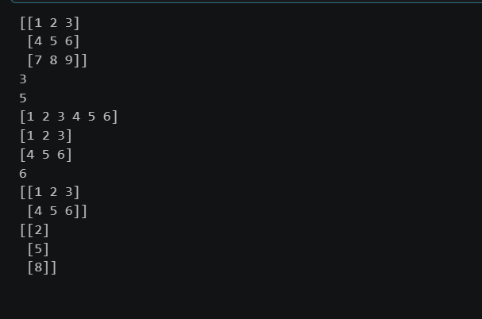

Activity: 03

#Load Library
import numpy as np

#Create a Matrix
matrix = np.array([[1,2,3],[4,5,6],[7,8,9]])

#View the Number of Rows and Columns
print(matrix.shape)

#View the number of elements (rows*columns)
print(matrix.size)

#View the number of Dimensions(2 in this case)
print(matrix.ndim)

Output:
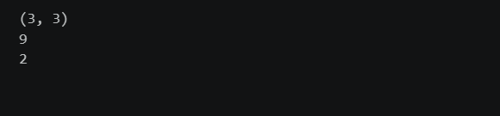

Activity: 04
#Load Library
import numpy as np

#Create a Matrix
matrix = np.array([[1,2,3],[4,5,6],[7,8,9]])
print(matrix)

#Return the max element
print(np.max(matrix))

#Return the min element
print(np.min(matrix))

#To find the max element in each column
print(np.max(matrix,axis=0))

#To find the max element in each row
print(np.max(matrix,axis=1))

Output:
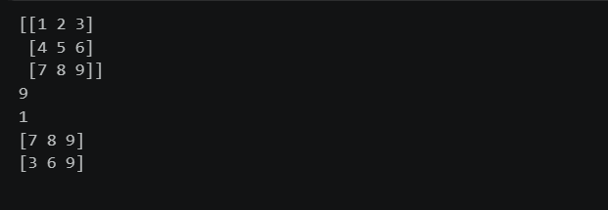

Activity: 05
#Load Library
import numpy as np

#Create a Matrix
matrix = np.array([[1,2,3],[4,5,6],[7,8,9]])
print(matrix)

#Reshape
print(matrix.reshape(9,1))

#Here -1 says as many columns as needed and 1 row
print(matrix.reshape(1,-1))

#If we provide only 1 value Reshape would return a 1-d array of that length
print(matrix.reshape(9))

#We can also use the Flatten method to convert a matrix to 1-d array
print(matrix.flatten())

Output:
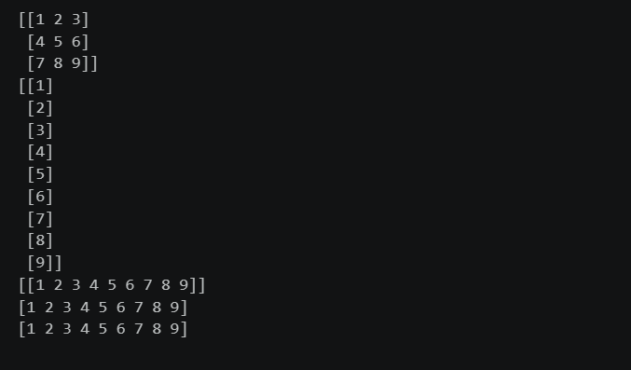

Activity: 06
#Load Library
import numpy as np

#Create a Matrix
matrix = np.array([[1,2,3],[4,5,6],[7,8,9]])
print(matrix)

#Transpose the matrix
print(matrix.T)
Output:
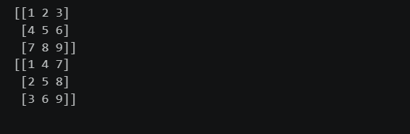

Activity: 07

#Load Library
import numpy as np

#Create vector-1
vector_1 = np.array([ 1,2,3 ])

#Create vector-2
vector_2 = np.array([ 4,5,6 ])

#Calculate Dot Product
print(np.dot(vector_1,vector_2))

#Alternatively you can use @ to calculate dot products
print(vector_1 @ vector_2)

Output:



Activity: 08

#Load Library
import numpy as np

#Create vector-1
vector_1 = np.array([ 1,2,3 ])

#Create vector-2
vector_2 = np.array([ 4,5,6 ])

#Calculate Dot Product
print(np.dot(vector_1,vector_2))

#Alternatively you can use @ to calculate dot products
print(vector_1 @ vector_2)

#The array method gives the same result
print(vector_1.dot(vector_2))

Output:


Activity: 09
#Load Library
import numpy as np

#Set seed
np.random.seed(1)

#Generate 3 random integers b/w 1 and 10
print(np.random.randint(0,11,3))

#Draw 3 numbers from a normal distribution with mean 1.0 and std 2.0
print(np.random.normal(1.0,2.0,3))

Output:

